Dot Net Core Interview Topics

Difference between Dot Net Framework & Dot Net Core

Q) difference between dot net framework and dot net core ?
can you explain briefly?

A: Here’s a simple, brief comparison between .NET Framework and .NET Core (now part of modern .NET):

🔹 .NET Framework
- Developed by Microsoft (older platform)
- Windows-only
- Monolithic (everything comes together as one big framework)
- Mainly used for:
  - Desktop apps (WinForms, WPF)
  - Older enterprise web apps (ASP.NET)
- Not actively enhanced (only maintenance updates)

🔹 .NET Core (Modern .NET)
- Also by Microsoft
- Cross-platform (Windows, Linux, macOS)
- Modular and lightweight
- High performance
- Used for:
  - Web apps (ASP.NET Core)
  - Cloud & microservices
  - APIs and modern applications
- Actively developed (now unified under ".NET 5+")

⚡ Key Differences
Feature | .NET Framework | .NET Core / Modern .NET
Platform | Windows only | Cross-platform
Performance | Moderate | Faster
Deployment | System-wide | Self-contained possible
Development status | Maintenance | Active
Use case | Legacy apps | New apps

🧠 In Short:
- Use .NET Framework → for maintaining old Windows apps
- Use .NET Core / .NET → for building new, modern, cross-platform apps

If you want, I can give a real-world example or a simple analogy to make it even clearer.
can you give version inforation from olden days onwords provide me.very clearly
Here’s a clear timeline of .NET versions from the early days to now, split into .NET Framework and .NET Core / Modern .NET:

🕰️ .NET Version History (Simple & Clear)
🔹 .NET Framework (Old / Windows-only era)
Version | Year | Key Notes
1.0 | 2002 | First release by Microsoft
1.1 | 2003 | Small improvements
2.0 | 2005 | Major update (Generics introduced)
3.0 | 2006 | Added WPF, WCF, WF
3.5 | 2007 | Introduced LINQ
4.0 | 2010 | Improved performance, parallel programming
4.5 – 4.8 | 2012–2019 | Incremental updates (async/await, etc.)
👉 Last version: 4.8 (still supported but no new features)

🔹 .NET Core (New Cross-Platform Start)
Version | Year | Key Notes
Core 1.0 | 2016 | First cross-platform version
Core 2.0 | 2017 | More stable, widely adopted
Core 2.1 | 2018 | LTS (Long Term Support)
Core 3.0 | 2019 | Added desktop support (WPF, WinForms)
Core 3.1 | 2019 | LTS, very popular

🔹 Modern Unified .NET (After Core)
(They dropped “Core” name after this)
Version | Year | Key Notes
.NET 5 | 2020 | Unified platform begins
.NET 6 | 2021 | LTS, very stable
.NET 7 | 2022 | Performance improvements
.NET 8 | 2023 | LTS, current widely used
.NET 9 | 2024 | Latest (short-term support)

📌 Important Understanding
- .NET Framework → Old (Windows only)
- .NET Core → Transition phase
- .NET 5+ → Modern unified platform

🧠 Easy Way to Remember
👉 Think like this:
- 2002–2019 → .NET Framework era
- 2016–2019 → .NET Core era
- 2020+ → Modern .NET (future)

If you want, I can also give:
✅ Interview questions
✅ Which version you should learn today
✅ Real project examples for each version

PROGRAM.CS SECTION

this program.cs is divided into 2 sections
section1:builder is the inbuilt dependency injection container. we need to register our all application dependencies into our inbuilt dependency injection container.
*this container will load your dependencies and then it will inject those dependencies to the controller class by using constructor injection and then we can use those dependencies in the controller class to perform the required operations.

#region inbuilt dependency injection containerSection.
var builder = WebApplication.CreateBuilder(args);

Add services to the container.

builder.Services.AddControllers();
// Learn more about configuring Swagger/OpenAPI at https://aka.ms/aspnetcore/swashbuckle
builder.Services.AddEndpointsApiExplorer();
builder.Services.AddSwaggerGen();

//builder is the inbuilt dependency injection container which is used to register the services and the repositories in the dependency injection container of the application and then we are building the application and running it.
//if you run the program,first it will call program.cs and it will load all the depencies into the memory and then it will inject those depencies to the controller class by using constructor injection and then we can use those depencies in the controller class to perform the required operations
// If you want to add any depencencies to your container. by using builder.services....we can register our dependicies.
#endregion

//section2:app is the inbuilt request pipeline,heare we need to register our middlewares to application pipeline.
//=========================================================================

var app = builder.Build();//this is one request pipeline,whenever we run the application,first it will call program.cs and it will create the request pipeline.
//all middleware we need to configure/register /adding to this request pipeline
//whenever if you add any middleware to request pipeleine order wise it will exceute.
// middleware naming convention starts with use keyword.
//====================This is one middleware ..we can create n no of middlewares as per our requirment
//here we are adding the inline middleware to the request pipeline by using app.use() method and we are writing the logic of the middleware inside the app.use() method.
//whatever the order we register the middleware in the request pipeline same order it will execute,if any middleware executes successfully it will pass the request to next middleware,if its fail/Shortcurit it will stop the middleware execution and throwing the error.
app.Use(async (context, next) => {//app.Use for Inline middlewares,write all logic inside the method,this is called inline middleware.
await context.Response.WriteAsync("Hello I am From user9");
await next.Invoke();//next will call the next middleware
});

//Use method add a middleware to the request pipeline.based on order you registered to request paipeleine.
//it will exceute same order.
app.Use(async (context, next) => {//app.Use for Inline middlewares
await context.Response.WriteAsync("Hello I am From user2");
await next.Invoke();//next will call the next middleware
});
app.Use(async (context, next) => {//app.Use for Inline middlewares
await context.Response.WriteAsync("Hello I am From user3");
await next.Invoke();//next will call the next middleware
});
app.Use(async (context, next) => {//app.Use for Inline middlewares
await context.Response.WriteAsync("Hello I am From user4");
await next.Invoke();//next will call the next middleware
});
app.Use(async (context, next) => {//app.Use for Inline middlewares
await context.Response.WriteAsync("Hello I am From user5");
await next.Invoke();//next will call the next middleware
});
app.Use(async (context, next) => {//app.Use for Inline middlewares
await context.Response.WriteAsync("Hello I am From user6");
await next.Invoke();//next will call the next middleware
});
app.Use(async (context, next) => {//app.Use for Inline middlewares
await context.Response.WriteAsync("Hello I am From user7");
await next.Invoke();//next will call the next middleware
});
app.Use(async (context, next) => {//app.Use for Inline middlewares
await context.Response.WriteAsync("Hello I am From user8");
await next.Invoke();//next will call the next middleware
});
app.Use(async (context, next) => {//app.Use for Inline middlewares
await context.Response.WriteAsync("Hello I am From user1");
await next.Invoke();//next will call the next middleware
});

app.Run();

DEPENDENCY INJECTION

1.What is dependency injection and how to implement it in .NET Core?
========================================================================
A)
1.Dependency injection is a design pattern.
2.which is used to develop the loosely coupling between the classes.
3)To implement loosely coupling between the classes ,by using interfaces and interface implemented classes we can achieve the dependency injection.
4)Dependency injection is avoid the tightly coupling between the classes.
that means we can't create direct object of the class in another class to access the members of that class.
5)In old application development we are creating the object of the class in another class to access the members of that class.
6)but in dependency injection we are not creating the object of the class in another class to access the members of that class.
7)these interfaces we are injecting to controller class by using constructor injection.
8)After that in program.cs we have inbuilt dependency injection container available, that is called builder and in builder that we need to register our dependencies.,
interfacename and interface implemented classes Register into builder.Services object using any one of AddScoped or AddSingleton or AddTransient methods.

2)Can you explain Dependency injection TYPES At Controller level?

we can implement in 3 ways at controller level
1.constructor injection
2.property injection
3.method injection
**You can use any one of the type real time mainly used constructor injection.

3)What is the constructor injection process?

A)
In the constructor injection, inject/pass the dependencies to the constructor injection means add your dependencies to constructor. class level dependencies adding in constructor.
create private readonly field of the interface type and then we can use that private readonly field to access the members of the service class in the controller class.

4)Can you explain dependency injection at program.cs level? (or) can you explain dependency injection service life time methods?(or) can you explain service life time methods in dependency injection?
can you explain briefly about AddSingleton, AddScoped and AddTransient methods in dependency injection?(or) what are the differences between AddSingleton,AddScoped and AddTransient methods in dependency injection?

A)
In program.cs we have three types of dependency injection life time methods are there,they are:
1)AddSingleton
2)AddScoped
3)AddTransient
======================
1)AddSingleton method:
Services.Addsingleton() method:
===========================
By using singleton service it created only one object and it is used for all httpRequests.
that same object is used for all the times.
if you call same method multiple times also it generates only one object in runtime.
this is called singleton design pattern.
for entire project we are reading the connection string only one time and that connection string information is used for all the times in the repository layer to connect to the database and perform the required crud operations.
in my project we are registering the connection factory class in the dependency injection container of the application using the AddSingleton method because we are reading the connection string only one time and that connection string information is used for all the times in the repository layer to connect to the database and perform the required crud operations.
builder.Services.AddSingleton<IConnectionFactory, ConnectionFactory>();

2)AddScoped method:
Services.Addscoped() method:

By using Addscoped service every httprequest new instance/object is created.
(whether it is get(or) post(or)put(or)delete opertions, each and every request new instance/object is created for scoped service).
in my project we are registering the repository interfaces and their implementation classes and service interfaces and their implementation classes in the dependency injection container of the application using the AddScoped method because we want to create new instance/object for every http request to access the members of the repository and service classes in the controller class to perform the required operations.
builder.Services.AddScoped<IEmployeeRepository, EmployeeRepository>();
builder.Services.AddScoped<IEmployeeService, EmployeeService>();

3)AddTransient method:
Services.AddTransient() method:
===============================
If any 3rd party apis comunication in your Api we can go for this services.
AddTransient() method.

By using Add Transient service each and every request new instance is created.
if you have any subsequent request it will create another object also.
Note:In one api if you call another api i.e is subsequent request.

Note:
• Services.Addscoped and services.addtransient almost same.
The main difference is if you have any subsequent request(or)3rdparty api calling in your service go for services.add transient().
if any database crud opertions in your service go for services.addscoped().

//if you want to call any 3rd party api urls calling scenario use AddTraniscent();
in my project we are using like below way to register the user repository and user service in the dependency injection container of the application using the AddTransient method because we are calling 3rd party api urls in the user repository class to get the data from that 3rd party api urls and then we are sending that data to the controller class and then we are sending that data to the client in a single response.
builder.Services.AddTransient<IUserService, UserService>();
builder.Services.AddTransient<IUserRepository, UserRepository>();

MIDDLEWARES

1.What is Middleware? how many Ways we create the middleware's ?
A)=>Middleware process Request and Response to the Application pipeline.
Middleware executed in Sequence order.
Whatever order you register in the application pipeline same order it will execute
=>if middleware executes successfully it will pass the request to next middleware.if its fail/Shortcurit it will stop the middleware execution and throwing the error.
=>all middlewares we need to register in the program.cs having a inbuilt request pipeline is there,that is called "app".in this app we need to register our middlewares to application pipeline.middleware naming convestion Starts with use keyword.
=>we can create the middlewares 2 ways.
1)inline middleware.
2)custom middleware.
================
1)inline middleware:
====================
=>inline middleware is a simple way to create the middleware.
we can create the inline middleware in program.cs file.
we can create the inline middleware by using app.use() method.
we can write the logic of the middleware inside the app.use() method.

LOGS

Q) How many ways we can log the messages in dot net core?
A:
* 3 ways we can log the messages in dotnet core:
* (1) By using Serilog we can log the messages in text file.
* (2) By using your ORM and custom logging factory we can log the messages in database.
* (3) by using Azure Application Insights Service we can log the messages in azure cloud(for this azure need to pay the money, very expensive).
Q)how to log the messages in text file using serilog:(or)How to log the messages in dot net core?
A:
By using Serilog we can log the messages in text file and
* also we can log the messages in database by using custom logging factory.
* and also by using Azure Application Insights we can log the messages in azure cloud.
* 1.First Install the serilog.Aspnetcore nuget package in your project.
* 2.Next We need to register Serilog to our dependency Injection Conatiner with below code.
* ===============================================================
* builder.Host.UseSerilog((context, configuration) =>
configuration.ReadFrom.Configuration(context.Configuration));
* ==========================================================
* 3.Use the Log.Information(), Log.Error(), Log.Warning() methods to log the messages in your code.
* 4)in appsettings.json file we need to add the serilog configuration code to specify the log file path and other settings for serilog.
* ################################################################
Q)how to log the messages in database using custom logging factory?
A:
* =>We can also log the messages using serilog and customlogging factory.
*
* 1.Create a logging factory class that implements an interface for logging.
* 2.Inside the logging factory class, create a method that takes the log message and other relevant information as parameters and saves it to the database using Dapper or any other data access method.
* 3.Inject the logging factory into your controller or service class where you want to log the messages and call the logging method with appropriate parameters whenever you want to log a message.

TOKENBASED AUTHENTICATION:

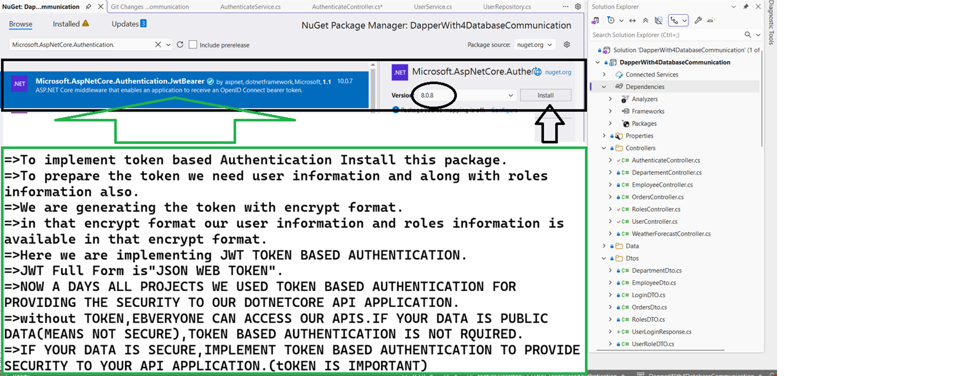
AGILE METHODOLOGY:
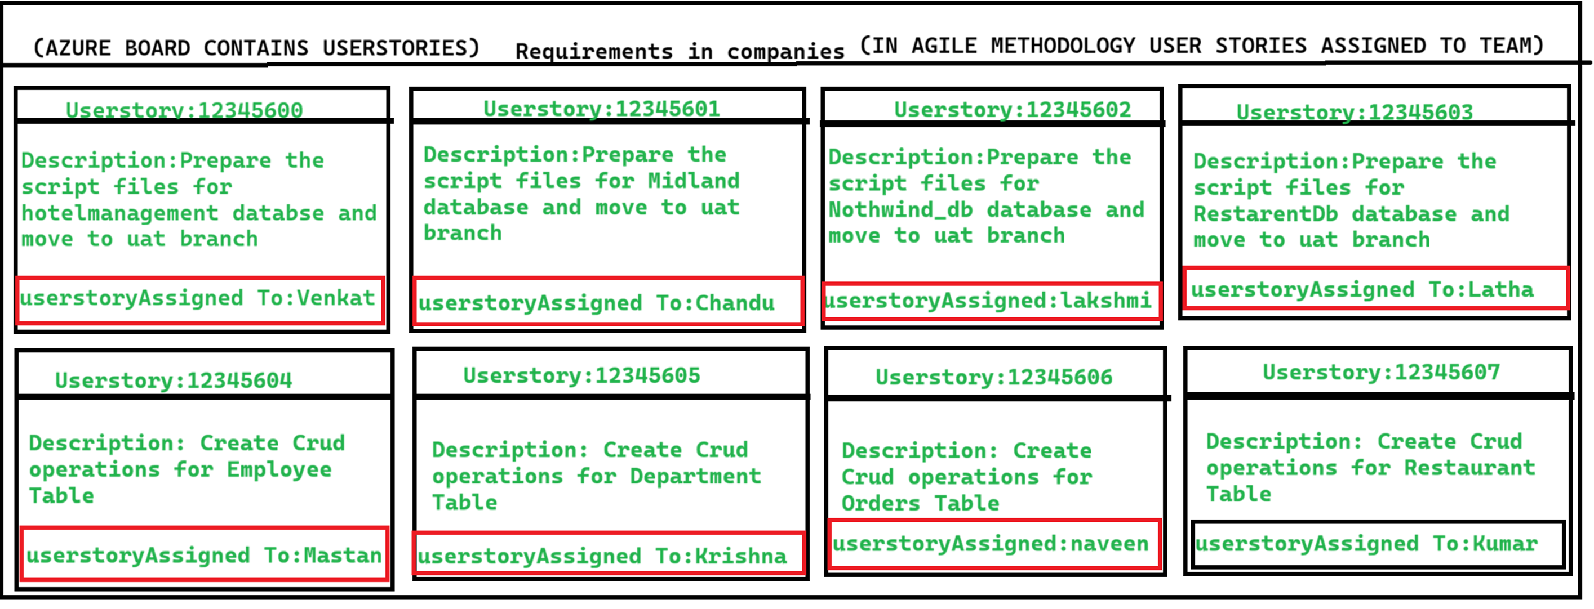
SOLID-PRINCIPLES:

what is solid principles explain each one?
=================================
what is solidprincples explain?
==========================
SOLID principles are 5 important Object-Oriented Design principles used in C#/.NET and other programming languages to write:
- Clean code
- Maintainable code
- Reusable code
- Flexible applications
SOLID stands for:
Letter | Principle
S | Single Responsibility Principle
O | Open/Closed Principle
L | Liskov Substitution Principle
I | Interface Segregation Principle
D | Dependency Inversion Principle

1. Single Responsibility Principle (SRP)
Definition
A class should have only one reason to change.
That means one class should do only one job.
Wrong Example

class Employee
{
public void SaveEmployee()
{
// Save to DB
}

public void GenerateReport()
{
// Generate Report
}
}

This class has 2 responsibilities:
- Saving employee
- Generating report
Correct Example

class EmployeeRepository
{
public void SaveEmployee()
{
// Save to DB
}
}

class ReportGenerator
{
public void GenerateReport()
{
// Generate Report
}
}

Interview Short Answer
“One class should handle only one responsibility.”

2. Open/Closed Principle (OCP)
Definition
Software entities should be:
- Open for Extension
- Closed for Modification
Meaning:
You should add new functionality without changing existing code.
Wrong Example

class Discount
{
public double GetDiscount(string type)
{
if(type == "Regular")
return 10;
else if(type == "Premium")
return 20;

return 0;
}
}

If new customer type comes, we modify class again.

Correct Example

abstract class Customer
{
public abstract double GetDiscount();
}

class RegularCustomer : Customer
{
public override double GetDiscount()
{
return 10;
}
}

class PremiumCustomer : Customer
{
public override double GetDiscount()
{
return 20;
}
}

Interview Short Answer
“Existing code should not change when new functionality is added.”

3. Liskov Substitution Principle (LSP)
Definition
Derived class should be able to replace base class without breaking application behavior.
Wrong Example

class Bird
{
public virtual void Fly()
{
}
}

class Ostrich : Bird
{
public override void Fly()
{
throw new Exception("Ostrich can't fly");
}
}

Problem:
Ostrich is a bird but cannot fly.

Correct Example

class Bird
{
}

interface IFly
{
void Fly();
}

class Sparrow : Bird, IFly
{
public void Fly()
{
}
}

class Ostrich : Bird
{
}

Interview Short Answer
“Child class should properly replace parent class.”

4. Interface Segregation Principle (ISP)
Definition
Clients should not be forced to implement methods they do not use.
Wrong Example

interface IWorker
{
void Work();
void Eat();
}

class Robot : IWorker
{
public void Work()
{
}

public void Eat()
{
// Robot doesn't eat
}
}

Correct Example

interface IWork
{
void Work();
}

interface IEat
{
void Eat();
}

class Human : IWork, IEat
{
public void Work() { }
public void Eat() { }
}

class Robot : IWork
{
public void Work() { }
}

Interview Short Answer
“Create small specific interfaces instead of one large interface.”

5. Dependency Inversion Principle (DIP)
Definition
High-level modules should not depend on low-level modules.
Both should depend on abstractions.
Wrong Example

class Email
{
public void Send()
{
}
}

class Notification
{
private Email email = new Email();

public void Notify()
{
email.Send();
}
}

Problem:
Notification tightly depends on Email.

Correct Example

interface IMessage
{
void Send();
}

class Email : IMessage
{
public void Send()
{
}
}

class SMS : IMessage
{
public void Send()
{
}
}

class Notification
{
private IMessage message;

public Notification(IMessage msg)
{
message = msg;
}

public void Notify()
{
message.Send();
}
}

Interview Short Answer
“Depend on interfaces, not concrete classes.”

Easy Memory Trick
Principle | Easy Meaning
S | One class → One job
O | Extend without modifying
L | Child should behave like parent
I | Small interfaces are better
D | Depend on abstraction

Real-Time Example in .NET
- SRP → Service layer separate from Repository
- OCP → Add new payment methods easily
- LSP → Derived services work like base service
- ISP → Small interfaces like ILogger, IEmailSender
- DIP → Dependency Injection in ASP.NET Core

Common Interview Question
Why SOLID principles are important?
Answer:
- Improves code maintainability
- Reduces tight coupling
- Makes code reusable
- Easier testing
- Easier scalability
- Better readability

CORS-DESCRIPTION

==================cors explanation=========
In your ASP.NET Core CORS configuration:
builder.Services.AddCors(options =>
{
options.AddPolicy("axisbankPolicy", policy =>
{
policy.WithOrigins(origins)
.AllowAnyHeader()
.WithMethods("*")
.WithExposedHeaders("*");
});
});
Header means HTTP headers — extra metadata sent along with HTTP requests and responses.
1. AllowAnyHeader()
This allows the client (browser/frontend) to send any request headers to your API.
Examples of request headers:
Authorization: Bearer token123
Content-Type: application/json
Accept: application/json
X-Custom-Header: abc
Without allowing headers, browsers may block requests containing custom headers during CORS checks.
Example:
.AllowAnyHeader()
means:
"Frontend can send any headers while calling this API."
Equivalent specific version:
.WithHeaders("Content-Type", "Authorization")

2. WithExposedHeaders("*")
Normally browsers only allow frontend JavaScript to read a few response headers.
This setting exposes response headers to the frontend.
Example response headers:
Content-Disposition: attachment
X-Token: abc123
X-RateLimit: 100
If you want Angular/React/JS to read them:
response.headers.get("X-Token")
then backend must expose them.
Example:
.WithExposedHeaders("*")
means:
"Frontend can access all response headers."
More secure version:
.WithExposedHeaders("X-Token", "Content-Disposition")

3. About WithMethods("*")
Actually this is incorrect usage.
WithMethods() expects explicit methods:
.WithMethods("GET", "POST", "PUT", "DELETE")
If you want all methods, use:
.AllowAnyMethod()

Correct Version
builder.Services.AddCors(options =>
{
options.AddPolicy("axisbankPolicy", policy =>
{
policy.WithOrigins(origins)
.AllowAnyHeader()
.AllowAnyMethod()
.WithExposedHeaders("*");
});
});
Where:
string[] origins =
{
"https://example.com",
"https://abc.com"
};
origins means which frontend domains are allowed to call your API.

AUTOMAPPER

1.what is Automapper?
A:
1)Auto mapper is used to create a mapping between to source model object to destination model object

2)once mapping is created, source model object can be converted to destination model object with less code and easy way.

3)Auto mapper can be instaled by using NUEGet Manage packager.

4) This required two steps:

1) creating mapping

syntax: mapper.createmap < sourcemodel object,destination modelobject >();

Here <> Means We called as a Placeholder .

2) Converting source modelobject to destination modelobject

destination modelclass Reference variable= Mapper.Map<destination modelclassname>(source modelclasspbject)

//===================================================

//Converting source modelobject to destination modelobject
//Syntax: _mapper.Map(SourceModelObject,DestinationModelObject)
//once mapping is created, source model object can be converted to destination model object with less code and easy way.

API methods testing ways

To Test OUR API'S 4 ways we can test.
=============================
1.Swagger
2.Postman
3.Insomania
4.Thunder client in visual studio code .

By using these four tools(or)rest clients we can send the request to respective api controller and inside the apimethod(or)http method.

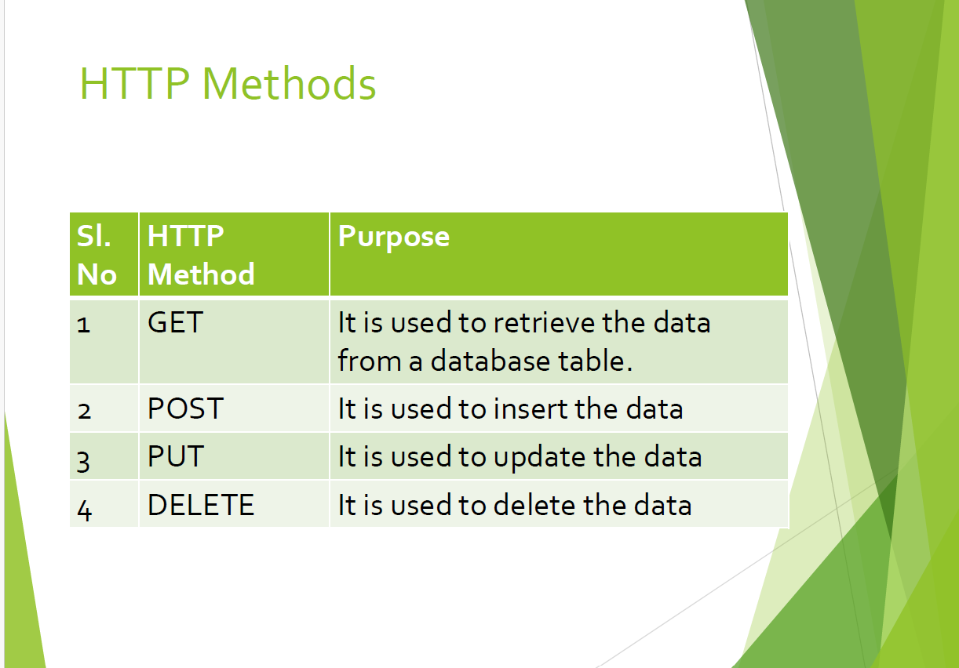

🔹 Quick Comparison
Attribute | Source | Example URL / Data
[FromRoute] | URL path | /api/products/5
[FromQuery] | Query string | ?name=abc&page=1
[FromBody] | Request body | JSON data

Common status code methods

🔹 Common Status Code Methods
These are helper methods inside controllers:
Method | Status Code | Meaning
Ok() | 200 | Success
Created() | 201 | Resource created
NoContent() | 204 | Success but no data
BadRequest() | 400 | Invalid input
Unauthorized() | 401 | Not logged in
Forbidden() | 403 | No permission
NotFound() | 404 | Data not found
StatusCode() | Any | Custom

JSON FORMAT

What is JSON?
JSON (JavaScript Object Notation) is a lightweight format used to store and exchange data between systems (like APIs).
Basic JSON Syntax
{
"id": 1,
"name": "John",
"isActive": true,
"skills": ["C#", ".NET", "SQL"]
}
Key Rules
- Data is in key-value pairs
- Keys are always strings (in quotes)
- Values can be:
  - string → "John"
  - number → 1
  - boolean → true
  - array → []
  - object → {}

Dapper:

================================================
1)Dapper is a simple Object-relational mapping (ORM).which is used to communicate with database and return the values.
2)it is similar like ado.net .
3) It owns the Title of King of Micro ORM in terms of speed.

****If you want to work with dapper orm we need to fallow below steps.*********
1)First we need to install the Dapper package from nuget package manager.
2)Next Creates an IDbConnection Object to store the sqlconnection.
3)once assign sqlconnection to Idbconnection object,after that this Idbconnection object having below methods to communicate with database.
1.QueryAsync() method which is used for Getting Listof data,GettingdatabyId purpose used.
2.ExecuteScalarAsync() method which is used for inseting,updting,deleting purpose used.
Note:Based on requirement you can use QueryAsync() method& ExecuteScalarAsync() method
=====================================================

ADO.NET:

**Exceutescalar(),ExceuteReader(),ExecuteNonQuery() methods used only in connection oriented model only.
//Open() and Close() methods are used in only connection oriented model.it opens the connection and close the connection will perform by these open() and close() methods.
//Disconnected oriented model SqlDataAdapter class will take care of all Query excutions like(All crud opertions)
//CRUD OPERTIONS MEANS(create,read(select command),update,delete) opertions.
//Open() and Close() methods are NOT used in Disconnected oriented model.
//ExecuteNonQuery() method used in connection oriented model only.it will exceute insert,update,delete statements.ExecuteNonQuery() method not used in discponnected oriented model.

EFWC CODE FIRST &DB FIRST APPROACH

1.Can you please explain Entity Framework code first approach process?
========================================================================
=>By using Code first approach we are generating the database and tables , based on entity classes or model classes.
Step1:=>To implement Code first Approach first install 3 packages
1.microsoft.entityframeworkcore(8.0.0)-- this version is used for .Net 8.0[ex:if u use .net6.0 version ,u will use entityframeworkcore (6.0.0)]
2.microsoft.entityframeworkcore.sqlserver(8.0.0)--[package is used to communicate with a sql server database]
3.microsoft.entityframeworkcore.tools(8.0.0)--[package is used to excute the entityframework core commands in package manager console window]
======================
Step2:=>Next creare the connection string in appsettings.json
Step3:=>create the modelclasses/entity classes
Step4:=>these entity classes register in the context class by using dbset<modelclassname>

Step5:=>After that register your contextclassname in program.cs by using builder.Services.AddDbContext<contextclassname>(place your connectionstring)
Step6:=>once you preapre these steps, after that we need to run 2 commands for generting the database.
1.ADD-MIGRATION Migrationname --command used to generate the migration folder.[which contains meta data of entity clases]
2.UPDATE-DATABASE --command is used to generate the database from developer side in .netcore
NOTE:if u r not using these commands,database not generated.
==================================

2.for example if you have more than one context file is available how you will apply the migrtions.can you explain the process?
====================================================
####################Facing Issues with Multiple Context Files#################################
In your dotnet core project if you communicate with 3 databases ,you will get 3 Context files.if you want to update any context file you must specify context name.
iF you want to communicate with multiple databases in dotnet core project we need to fallow these rules.
other wise you will face this below issue.

====================multiple context class updation error====
ERROR:More than one DbContext was found. Specify which one to use.
Use the '-Context' parameter for PowerShell commands and the '--context' parameter for dotnet commands.
=======================To fix this above issue we fallowed below commands==============
=============iF you want to communicate with multiple databases in dotnet core project we need to fallow these rules.
======syntax for code first approcah updations=======

Add-Migration MigrationName -Context ContextClassName

update-database -Context ContextClassName

Note:
1)Here Migration name you can give any migrationName.
2)Make sure you need to mention the context classname.other wise it will throw the above error.

===========Usageof CodeFirst approach updations=======

Add-Migration Project -Context EmployeeManagementContext

update-database -Context EmployeeManagementContext
==================================================

* to implement db first approach use this command
* ===================================================

PM> Scaffold-DbContext "Server=DESKTOP-13B42NJ;Database=hotelmanagement;Trusted_Connection=True;TrustServerCertificate=True;MultipleActiveResultSets=True;" Microsoft.EntityFrameworkCore.SqlServer -OutputDir hotelmanagementModels
=================================

ERROR:
=======
i am using entity framework core db first approach ,
by using sccaffold-dbcontext i already generted context class and model classes ,
if i perform add opetion it is thorwing primary key below error
.aftet hat i have applied primary key empid column in database and again when
i perform ad opertion it is not added record in database.
i want to update the db changes again into Sccafold-dbcontext command.how?
i want to update the database chnages to my context class again
how we can perfome in ef core db first approach?

TO FIX THE ABOVE ISSUE BELOW IS THE SOLUTION:
==================================================
roblem 1: “Entity has no primary key”

Error:

Unable to track an instance of type 'Employee' because it does not have a primary key

This happens because when you first ran Scaffold-DbContext, your table didn’t have a primary key, so EF generated your Employee model without a key.

Even though you later added a PK in Microsoft SQL Server, your C# model is still outdated.

✅ Solution: Re-scaffold (update models from DB)

EF Core DB-first does NOT auto-sync. You must regenerate models.
================
BEFORE UPDATING THIS COMMAND FIRST IN DATABASE APPLY PRIMARY KEY TO THE ID COLUMN
creating the primary key after creating the table.(add below command in hotelmanagment database)
====================================

ALTER TABLE employee ADD CONSTRAINT PK_employee PRIMARY KEY (empid);

==========
ONCE YOU ADD PRIMARY KEY,APPLY BELOW COMMAND.
===================
🔹 Command to update models

Run the same command again with -Force:(USE -fORCE AT ENDING OF STATEMENT)IF ANY DB MODIFICATIONS PERFOMED AND TO EFFECT THOSE CHANGES TO OUR ENTITY CLASSES.
==========================================
PM>Scaffold-DbContext "Server=DESKTOP-13B42NJ;Database=hotelmanagement;Trusted_Connection=True;TrustServerCertificate=True;" Microsoft.EntityFrameworkCore.SqlServer -OutputDir hotelmanagementModels -Force
=============================

👉 -Force = overwrite existing models & DbContext
*/
To fix that primary key issue we need to add the primary key to that table
=====================================================
creating the primary key after creating the table.(add below command in NorthWin_db database)
====================================

ALTER TABLE Department ADD CONSTRAINT PK_Department PRIMARY KEY (deptid);

Jobs:

=>Jobs are used to run the script as per our Time requirement: if you want perform any manual operations we can automate byusing these jobs concept.
=>We can implement the jobs concept 2 ways
1)by using console application with ado.net application created and run and tested locally after that we can deploy into taskscheduler.
2)by using sqlserver Agent in sqlserver we can create the job and we can achieve it.

